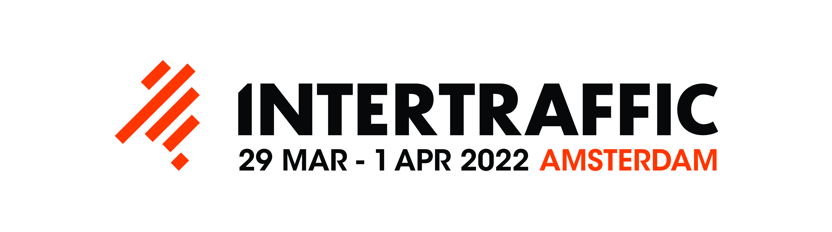

APPLICATION FOR THE INTERTRAFFIC SUMMIT & DEMONSTRATION PROGRAMME 2022
29 MAR - 1 APR 2022 | RAI Amsterdam

Applicant (please complete in English, typed or in block capitals only)

Mr /Mrs

Company name

Street and number

Postal code and city

Country

P.O. Box

Postal code and city

Telephone (general number)

Fax (general number)

Contact person

Telephone (direct line)

E-mail contact person

Job title

Website

Theme(s)

Subject of presentation
(see ‘official subject overview’)

Title of presentation or demo
(should be triggering for visitors and suitable to use in the registration module)

Target group(s)

Presentation & demonstration focus
O Policy and Strategy, institutional and organisational issues
O Supplier issues: product innovations, use cases, business models, deployment strategies, market development
O User issues: case studies, features for specific target groups, benefits and cost assessments
O Innovation, new technologies and standardization
O Trends & market developments, industry views, education and training

Summit & demo setting
O pitch presentation
O product & user experience demonstration
O interactive presentation
O debate
O panel discussion
O indoor demonstration O outdoor demonstration

Presentation timeslots Summit theatres
O € 650.00 for 30 minutes
O € 875.00 for 45 minutes
O € 1,100.00 for 60 minutes

(covers the construction of the theatres, stages, furniture, AV, support from technicians, and includes promotion via the Intertraffic marketing tools such as website and newsletters, includes Summit & demonstration activities publication in the exhibitor guide, and integrated advertising with other Intertraffic promotional activities).

Demonstration areas
O Indoor and outdoor demonstration area(s), ranging from € 495.00 to € 1,495.00
O Promo point near entrance € 4.180,00

Remarks
- The Summit committee will decide whether your presentation is suitable to be included in the Intertraffic Summit & Demonstration Programme.
Confirmations and time slot allocations will be sent in November 2021.
- Participation in the Intertraffic Summit & Demonstration Programme is possible, provided that you are an Intertraffic exhibitor or sponsor.
- Intertraffic will promote your presentation as much as possible via the Intertraffic promotion channels. However, we underline the importance of inviting your (potential) customers yourself, as well.

Short summary (max. 150 words)
(to be used in the Intertraffic registration module)

Long description of your presentation (max. 600 words)

Date: Company stamp and signature:

To be sent to Intertraffic no later than 1 October 2021.
RAI Amsterdam, P.O. Box 77777, 1070 MS Amsterdam, the Netherlands.

Esther de Waard – Programme Manager Intertraffic Amsterdam
Joyce de Winter – Exhibition Manager Intertraffic Amsterdam
P.O Box 77777
1070 MS Amsterdam
The Netherlands
Tel: +31 20 549 2289
E-mail: intertraffic@rai.nl

